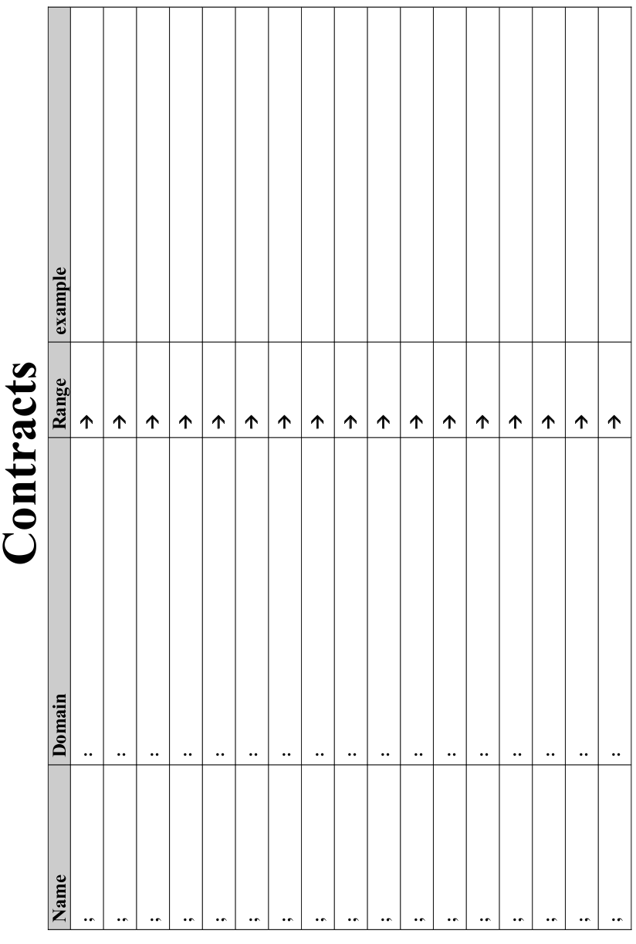

Lesson 1

Circles Competition Time: 5 minutes
 | Math | Circle of Evaluation | Scheme Code
Round 1 | (1 + 2) - (3 * 7)
Round 2 | 3 - (1 + 2)
Round 3 | 3 - (1 + (5 * 6))
Round 4 | (1 + (5 * 6)) - 3


Fast Functions!
Fill out the contract for each function, then try to write two examples and the definition by yourself.
; _double____________:__Number________ -> _Number________
name domain range
(EXAMPLE (_double_ __5__) _( * 2 5 )_____________)
(EXAMPLE (_double_ __7__) _( * 2 7 )_____________)
(define (__double_ _n____) _( * 2 n )________________)
; _________________:_________________ -> ________________
name domain range
(EXAMPLE (______ ________) _____________________________)
(EXAMPLE (______ ________) _____________________________)
(define (________ _______) ____________________________)
; _________________:_________________ -> ________________
(EXAMPLE (______ ________) _____________________________)
(EXAMPLE (______ ________) _____________________________)
(define (________ _______) ____________________________)
; _________________:_________________ -> ________________
(EXAMPLE (______ ________) _____________________________)
(EXAMPLE (______ ________) _____________________________)
(define (________ _______) ____________________________)

Lesson 2

Design Recipe: SAMPLE

State the problem:

Make a circle (spot) of size 100, with the provided color

Contract+Purpose Statement
Every contract has three parts:

; ___spot100____ : String -> Image
name Domain Range

; Makes a size 100 circle in a color What does the function do?

Give Examples
On the computer, write an example of your function in action, using EXAMPLE.

(EXAMPLE ( spot100 “green” )(circle 100 “solid” “green” ))
the user types… ...which should become
color

(EXAMPLE ( spot100 “blue” )(circle 100 “solid” “blue” ))
the user types… ...which should become

Function
Circle the changes in the EXAMPLEs, and name the variables.
Write the code, copying everything that isn't circled, and using names where you find variables!

(define (spot100 color ) (circle 100 “solid” color ))
function name variable names ...and the computer does this

Design Recipe: double-radius

State the problem:

Contract+Purpose Statement
Every contract has three parts:

; __________________ : _________________________________________ -> ______________
name Domain Range

; _______________________________________________________________________________
What does the function do?

Give Examples
On the computer, write an example of your function in action, using EXAMPLE.

(EXAMPLE (_______ _____________) _________________________________)
the user types… ...which should become

(EXAMPLE (_______ _____________) _________________________________)
the user types… ...which should become

Function
Circle the changes in the EXAMPLEs, and name the variables.
Write the code, copying everything that isn't circled, and using names where you find variables!

(define (_______ _____________) _________________________________)

Design Recipe: double-width

State the problem:

Contract+Purpose Statement
Every contract has three parts:

; __________________ : _________________________________________ -> ______________
name Domain Range

; _______________________________________________________________________________
What does the function do?

Give Examples
On the computer, write an example of your function in action, using EXAMPLE.

(EXAMPLE (_______ _____________) _________________________________)
the user types… ...which should become

(EXAMPLE (_______ _____________) _________________________________)
the user types… ...which should become

Function
Circle the changes in the EXAMPLEs, and name the variables.
Write the code, copying everything that isn't circled, and using names where you find variables!

(define (_______ _____________) _________________________________)

Design Recipe: paint-job

State the problem:

Contract+Purpose Statement

; __________________ : _________________________________________ -> ______________
name Domain Range
; _______________________________________________________________________________
What does the function do?

Give Examples
On the computer, write an example of your function in action, using EXAMPLE.

(EXAMPLE (______________ __________________________________)
___________________________________________
___________________________________________
___________________________________________
___________________________________________
___________________________________________)
(EXAMPLE (______________ __________________________________)
___________________________________________
___________________________________________
___________________________________________
___________________________________________
___________________________________________)

Function

(define (______________ _________________________________)
___________________________________________
___________________________________________
___________________________________________
___________________________________________
___________________________________________)

Design Recipe: turbo-charge

State the problem:

Contract+Purpose Statement

; __________________ : _________________________________________ -> ______________
name Domain Range
; _______________________________________________________________________________
What does the function do?

Give Examples
On the computer, write an example of your function in action, using EXAMPLE.

(EXAMPLE (______________ __________________________________)
___________________________________________
___________________________________________
___________________________________________
___________________________________________
___________________________________________)
(EXAMPLE (______________ __________________________________)
___________________________________________
___________________________________________
___________________________________________
___________________________________________
___________________________________________)

Function

(define (______________ _________________________________)
___________________________________________
___________________________________________
___________________________________________
___________________________________________
___________________________________________)

Lesson 3

Design Recipe: pimp

State the problem:

Contract+Purpose Statement

; __________________ : _________________________________________ -> ______________
name Domain Range
; _______________________________________________________________________________
What does the function do?

Give Examples
On the computer, write an example of your function in action, using EXAMPLE.

(EXAMPLE (______________ __________________________________)
___________________________________________
___________________________________________
___________________________________________
___________________________________________
___________________________________________)
(EXAMPLE (______________ __________________________________)
___________________________________________
___________________________________________
___________________________________________
___________________________________________
___________________________________________)

Function

(define (______________ _________________________________)
___________________________________________
___________________________________________
___________________________________________
___________________________________________
___________________________________________)

define-struct

Autos:

; an auto is a ______________________________________________

(define-struct auto (_________________
_________________
_________________
_________________
_________________))

; a party is a ______________________________________

(define-struct party (_________________
__________________
__________________))

Design Recipe: RSVP

State the problem:

Contract+Purpose Statement

; __________________ : _________________________________________ -> ______________
name Domain Range
; _______________________________________________________________________________
What does the function do?

Give Examples
On the computer, write an example of your function in action, using EXAMPLE.

(EXAMPLE (______________ __________________________________)
___________________________________________
___________________________________________
___________________________________________)
(EXAMPLE (______________ __________________________________)
___________________________________________
___________________________________________
___________________________________________)

Function

(define (______________ _________________________________)
___________________________________________
___________________________________________
___________________________________________)

Design Recipe: relocate

State the problem:

Contract+Purpose Statement

; __________________ : _________________________________________ -> ______________
name Domain Range
; _______________________________________________________________________________
What does the function do?

Give Examples
On the computer, write an example of your function in action, using EXAMPLE.

(EXAMPLE (______________ __________________________________)
___________________________________________
___________________________________________
___________________________________________)
(EXAMPLE (______________ __________________________________)
___________________________________________
___________________________________________
___________________________________________)

Function

(define (______________ _________________________________)
___________________________________________
___________________________________________
___________________________________________)

Dissecting a Demo: Ninja World
What changes?
_______________________________________________
_______________________________________________
_______________________________________________
_______________________________________________

Ninja World:
; a world is a _________________________________________

(define-struct world (_________________))

My constructor function is:
1) (How do you make a world?)__________________________
What is its contract? _________________________________
My accessor function is:
2) (How do you get the dogX out of the world?)
___________________________________________
What is its contract? _________________________________

Design Recipe: update-world (Ninja World)

State the problem:

Contract+Purpose Statement

; ________________ : _______________ -> ______________
name Domain Range
;__________________________________________________________
What does the function do?

Give Examples
On the computer, write an example of your function in action, using EXAMPLE.

(EXAMPLE (____________ ______________________)
___________________________________________)
(EXAMPLE (_________ _________________________)
___________________________________________)

Function

(define (___________ ___________________________)

___________________________________________)

Lesson 4

Review: define-struct
Last week we talked about a function that created new structs. For the structs below, what function would you use for each of the following?

; an auto is a String __________ Number ________ Number
(define-struct auto (model hp rims color value))
Make an auto? _______________________________
Get the model out of an auto? ___________________
Get the hp out of an auto? ______________________

; a party is a _______ String Number
(define-struct team (location theme guests))
Make a team? _________________________________
Get the city out of the team? _____________________
Get the sport out of the team? ___________________
Get the rank out of the team? ______________________
; a world is a Number
(define-struct world (dogX))
What function would you use to:
Make a world? ___________________________________
Get the dogX out of the world? ______________________

Game Design
“Start Simple, Get Complex”

Draw a rough sketch of your game in action

What images will you need for your game?
Background

List everything that has changed, and the datatype you will use to represent it
Changed (position? score? color? costume?) | Datatype (number? string? image? boolean?)

; a world is a _________________________________________
(define-struct world (_________________
_________________
_________________
_________________
_________________))

My constructor function is…

; make-world : _____________________________________ → World

My accessor functions are…
;______________________________________________
;______________________________________________
;______________________________________________
;______________________________________________
;______________________________________________

Lesson 5

(0, 480) START (640,480)
(0, 0) (640, 0)
At the start of my game, this is where everything is:
Object (top to bottom of stack) | Position (x, y)
Background

(define START(make-world _________________
_________________
_________________
_________________
_________________))
(0, 480) NEXT (640,480)
(0, 0) (640, 0)
A split second later, this is where everything is:
Object (top to bottom of stack) | Position (x, y)
Background

(define NEXT (make-world _________________
_________________
_________________
_________________
_________________))

draw-world

Contract

; __________________ : _________________________________________ -> ______________

Using put-image

(define (____________ _______________________________)
(put-image ________________
________________
(put-image ________________
________________
(put-image ________________
________________
(put-image ______________
_______________
BACKGROUND _______

Design Recipe: update-world

State the problem (What changes?):

Contract+Purpose Statement

; __________________ : _________________________________________ -> ______________
name Domain Range
; _______________________________________________________________________________
What does the function do?

Give Examples
On the computer, write an example of your function in action, using EXAMPLE.

(EXAMPLE (______________ __________________________________)
___________________________________________
___________________________________________
___________________________________________
___________________________________________
___________________________________________)
(EXAMPLE (______________ __________________________________)
___________________________________________
___________________________________________
___________________________________________
___________________________________________
___________________________________________)

Function

(define (______________ _________________________________)
___________________________________________
___________________________________________
___________________________________________
___________________________________________
___________________________________________)

Lesson 6
When the user presses… | this part... | Changes by…

Design Recipe

State the Problem
For each keypress in the Ninja World game, show how (keypress START <key>) should change your world.

Contract+Purpose Statement
; : ->
name Domain Ranges

Give Examples

(EXAMPLE (keypress START __________________________________)

(make-world _____________________________________

_____________________________________

_____________________________________

_____________________________________

_____________________________________))

(EXAMPLE (keypress START __________________________________)

(make-world _____________________________________

_____________________________________

_____________________________________

_____________________________________

_____________________________________))

(define (_______________ __________________________________)
(cond
[(_________________________________________________)

_____________________________________________________

_____________________________________

_____________________________________

_____________________________________

_____________________________________]

[(_________________________________________________)

_____________________________________________________

_____________________________________

_____________________________________

_____________________________________

_____________________________________]))

Design Recipe

State the Problem
For each keypress in your game, show how (keypress START <key>) should change your world.

Contract+Purpose Statement
; : ->
name Domain Ranges

Give Examples

(EXAMPLE (keypress START __________________________________)

(make-world _____________________________________

_____________________________________

_____________________________________

_____________________________________

_____________________________________))

(EXAMPLE (keypress START __________________________________)

(make-world _____________________________________

_____________________________________

_____________________________________

_____________________________________

_____________________________________))

(EXAMPLE (keypress START __________________________________)

(make-world _____________________________________

_____________________________________

_____________________________________

_____________________________________

_____________________________________))
___________________________________________________________________________________________________
(define (________________ __________________________________)
(cond
[(_________________________________________________)

_____________________________________________________

_____________________________________

_____________________________________

_____________________________________

_____________________________________]

[(_________________________________________________)

_____________________________________________________

_____________________________________

_____________________________________

_____________________________________

_____________________________________]

[(_________________________________________________)

_____________________________________________________

_____________________________________

_____________________________________

_____________________________________

_____________________________________]))

Lesson 7

Extended update-world:
; __off-right?___:_________________ -> ________________
name domain range
(EXAMPLE (__________ ______) _______________________)
(EXAMPLE (__________ ______) _______________________)
(define (__________ ______) _______________________)
; _off-left?___:_________________ -> ________________
(EXAMPLE (__________ ______) _______________________)
(EXAMPLE (__________ ______) _______________________)
(define (__________ ______) _______________________)
; ________________:_________________ -> ________________
(EXAMPLE (__________ ______) _______________________)
(EXAMPLE (__________ ______) _______________________)
(define (__________ ______) _______________________)
; ________________:_________________ -> ________________
(EXAMPLE (__________ ______) _______________________)
(EXAMPLE (__________ ______) _______________________)
(define (__________ ______) _______________________)

TEST | RESULT
(make-world ___________________________________
___________________________________
___________________________________
___________________________________
___________________________________)
(make-world ___________________________________
___________________________________
___________________________________
___________________________________
___________________________________)
(make-world ___________________________________
___________________________________
___________________________________
___________________________________
___________________________________)
(make-world ___________________________________
___________________________________
___________________________________
___________________________________
___________________________________)

Lesson 8

Design Recipe: line-length
Write a function called line-length, which takes in two numbers and returns the difference between them. It should always subtract the smaller number from the bigger one.

Contract+Purpose Statement
Every contract has three parts:

; __________________ : _________________________________________ -> ______________
name Domain Range

Give Examples

(EXAMPLE ( _______________ ______) ______________________ )

(EXAMPLE ( _______________ ________________) ______________________)

Function Header
Write the Function Header, giving variable names to all your input values that change.

(define (____________ ___________________)
function name variable names

________________________________

))

Distance:

The Player is at (4, 2) and the Target is at (0, 5).
Distance takes in the player-x, player-y, character-x and character-y.

Use the formula below to fill in the EXAMPLE:
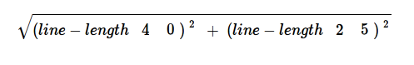

Convert it into a Circle of Evaluation. (We've already gotten you started!)

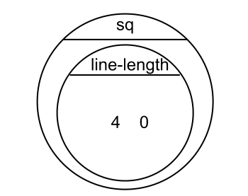

Convert it into Racket code:
(EXAMPLE (_______________ ______________________)

(________________________________________________

__________________________________________________)

Design Recipe: distance
Write a function distance,which takes FOUR inputs:
- px: The x-coordinate of the player
- py: The y-coordinate of the player
- cx: The x-coordinate of another game character
- cy: The y-coordinate of another game character

It should return the distance between the two, using the Distance formula:
Distance = ((line-length px cx)² + (line-length py cy)² )

Contract+Purpose Statement

; __________________ : _________________________________________ -> ______________
name Domain Range

; _______________________________________________________________________________
What does the function do?

Give Examples

(EXAMPLE (___________________________________________)

____________________________________________________)

(EXAMPLE (___________________________________________)

____________________________________________________)

Function Header

(define (____________ ___________________)
function name variable names

___________________________________________________)

Design Recipe: collide?

Write a function collide?,which takes FOUR inputs:
- px: The x-coordinate of the player
- py: The y-coordinate of the player
- cx: The x-coordinate of another game character
- cy: The y-coordinate of another game character
It should return true if the coordinates of the player are within 75 pixels of the
coordinates of the other character. Otherwise, false.

Contract+Purpose Statement

; __________________ : _________________________________________ -> ______________
name Domain Range

; _______________________________________________________________________________
What does the function do?

Give Examples

(EXAMPLE (___________________________________________)

_________________________________________________)

(EXAMPLE (___________________________________________)

_________________________________________________)

Function Header

(define (____________ ___________________)

________________________________________________)

TEST | RESULT
(make-world ___________________________________
___________________________________
___________________________________
___________________________________
___________________________________)
(make-world ___________________________________
___________________________________
___________________________________
___________________________________
___________________________________)
(make-world ___________________________________
___________________________________
___________________________________
___________________________________
___________________________________)
(make-world ___________________________________
___________________________________
___________________________________
___________________________________
___________________________________)

Supplemental

Design Recipe

State the problem:

Contract+Purpose Statement
Every contract has three parts:

; __________________ : _________________________________________ -> ______________
name Domain Range

; _______________________________________________________________________________
What does the function do?

Give Examples
On the computer, write an example of your function in action, using EXAMPLE.

(EXAMPLE (_______ _____________) _________________________________)
the user types… ...which should become

(EXAMPLE (_______ _____________) _________________________________)
the user types… ...which should become

Function
Circle the changes in the EXAMPLEs, and name the variables.
Write the code, copying everything that isn't circled, and using names where you find variables!

(define (_______ _____________) _________________________________)

Design Recipe

State the problem:

Contract+Purpose Statement
Every contract has three parts:

; __________________ : _________________________________________ -> ______________
name Domain Range

; _______________________________________________________________________________
What does the function do?

Give Examples
On the computer, write an example of your function in action, using EXAMPLE.

(EXAMPLE (_______ _____________) _________________________________)
the user types… ...which should become

(EXAMPLE (_______ _____________) _________________________________)
the user types… ...which should become

Function
Circle the changes in the EXAMPLEs, and name the variables.
Write the code, copying everything that isn't circled, and using names where you find variables!

(define (_______ _____________) _________________________________)

TEST | RESULT
(make-world ___________________________________
___________________________________
___________________________________
___________________________________
___________________________________)
(make-world ___________________________________
___________________________________
___________________________________
___________________________________
___________________________________)
(make-world ___________________________________
___________________________________
___________________________________
___________________________________
___________________________________)
(make-world ___________________________________
___________________________________
___________________________________
___________________________________
___________________________________)

